

LONG TERM CONDITIONS E-NEWS
July 2016

LoCAL NewS

Review shows new law has made little difference to England's unpaid Carers according to The Carers Trust
A year on from the introduction of the Care Act, a review by the UK’s largest charity for unpaid Carers has found that the new act has made little or no difference to the 5.4 million Carers in England.
Carers Trust surveyed and spoke to unpaid Carers looking after their sick or disabled family and friends, and to health and social care professionals to find out how well they thought the new act, which entitles Carers to an assessment of their needs, was working.
The review, led by former care minister Paul Burstow, found a ‘mixed picture’ with examples of good practice, but in many cases found that the act had made no difference to Carers. In some instances, Carers hadn’t heard about the measures that had been introduced, which could support their needs and well-being as a Carer.
The new Care Act came into force on 1 April 2015 and gave Carers rights on an equal footing to the people they care for. Their new rights include taking into consideration the Carer’s health and wellbeing, family relationships and their need to balance their home life with their education or work. If they are found to be eligible they are entitled to support, sometimes funded by their local authority. In addition, all local authorities must provide advice and information and prevent Carers’ needs from getting worse.
Former Care Minister, Prof Paul Burstow said:“For many of the Carers who responded to Carers Trust’s calls for evidence, the response was stark - the act had made no difference. It was news to some that there were new rights as they simply hadn’t heard of them.
The review received more than 800 responses, which included evidence from three days of oral hearings where a panel heard personal accounts from Carers as well as from leading health and care providers and Carers groups. It found:
- Only 21% of respondents felt that things had changed as a result of The Care Act 2014
- 65% of Carers who responded said they had not had an assessment, while 4% didn’t know whether or not they’d had an assessment
- Only 5% of respondents were non-white, suggesting that the act was failing to be implemented in Black and Minority Ethnic groups

Many Carers don’t see themselves as Carers which posed a problem identifying and supporting them, said Carers Trust.

Local Action on this issue

Carers IW a local carer support organisation has been working closely with carers across the Island ensuring that the ‘carer’s’ voice is heard. Many carers and professionals have identified that the current carers assessment is not fit for purpose, so the IWC have agreed that this document can be rewritten. They have a proposed draft Carers Assessment that we would like carers to trial and give us their comments, as we need to know what works for you. If you are interested in coming along please come along.

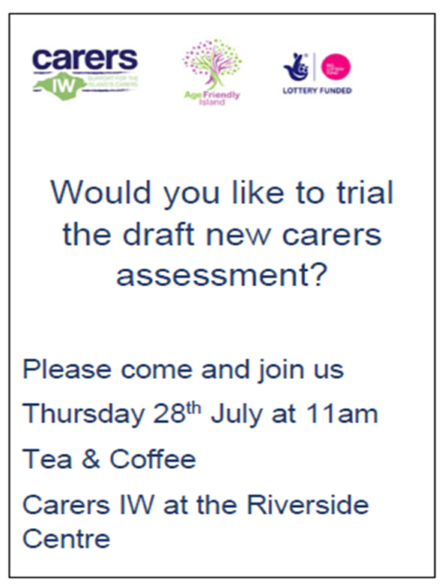
Isle of Wight Older Voices Forum – A chance to get together with others in your local community

The Isle of Wight Older Voices Forum held its Annual General Meeting at the Riverside on the 6th July. At the meeting there was feedback from two of the Older Voices Forum Circles, one from East Cowes and the other from Newport. The Circles meet once a month and provide an opportunity to meet people and learn about what’s going on both in the local community and on the Isle of Wight. Both groups reported having presentations from local councillors, the community policing service and Island Roads. To find out more you can contact the Chair of the Older Voices Forum, Helen Osborne on 01983 522208 e mail: oldervoices@outlook.com

Age UK Isle of Wight Good Neighbour Scheme

Are you over 50 and could use some help with any of the following?

- Having someone to talk to
- Outings or shopping.
- Transport to medical appointments.
- Walking the dog.
- Help with small tasks in the home.
- Letter writing or help with paperwork.
- Choosing, collecting and returning library books.
- Specialised support for the older LGBT community, working towards an inclusive Island.
- Confidential support for those suffering domestic abuse.
- Regaining confidence after illness or bereavement.

For outings and transport requests a small mileage fee will be payable to cover expenses.

For more information, and to see if a Good Neighbour Scheme volunteer could help you or a friend, please contact our friendly office on (01983) 525282 or email: gns@ageukiw.org.uk.

Age Friendly Island Public Forum

Would you like to take part in a discussion about transport on the Isle of Wight and patient transport to the mainland? Age UK Isle of Wight is running three Public Forums across the island in conjunction with Southern Vectis and other transport providers. Dates are as follows:

Monday 15th August – Aspire, Dover Street, Ryde. 2pm – 4 pm
Wednesday 17th August – Riverside Centre, Newport. 4pm – 6 pm
Thursday 18th August – Salisbury Gardens, Ventnor. 2pm – 4 pm

Light refreshments will be provided and transport can be arranged for those with mobility issues. For further information please contact Age UK Isle of Wight on 525282 and ask for Jess or Lauren, or e mail: hello@agefriendlyisland.org

Have Something To Say About Diabetes Care?

This year the All Party Parliamentary Group for Diabetes have launched a yearlong investigation under the theme Diabetes Care: improving standards and reducing variation.
To support our investigation we need to hear from people affected by diabetes, healthcare professionals, commissioners and policy experts. We therefore invite people to submit written evidence using one of the following guidance:

Written Evidence Guidance- Diabetes Care
We would also like to hear from people affected by diabetes, for which we have slightly different guidance for submitting evidence

People affected by diabetes – Guidance
The deadline for evidence submission is midnight 31 July 2016.

More information on the investigation and upcoming meetings can be found our websitehttps://diabetes-appg.co.uk/

Ehlers-Danlos Syndrome

Ehlers-Danlos syndrome (EDS) is a genetic disorder in which the structure of connective tissue is abnormal due to a gene mutation. This results in abnormally fragile and hyper-extensible tissues throughout the body which can lead to a range of multi-systematic symptoms. The effect on the body is widespread and not limited to one body system.

EDS UK was set up in 1987 to support, advise and inform those living with Ehlers-Danlos syndrome. There is now a local support group developing and if you are interested in knowing more about the group then please contact:

Jenny Girvin-Baker email: jennygb@btinterent.com

National Freephone helpline: 0800 907 8518/ info@ehlers-danlos.org

The Independent Living Centre

The Independent Living Centre has moved to 1 and 2 Bernard Way Newport PO30 5YL
They are having an ‘Open Day’ on 12th or 19th July from 10.00 till 15.00. All welcome.
NB There is limited parking to the front of their building
For all enquiries email Terri Baker: terribaker@peoplematteriw.org

Bipolar Disorder

Have you been diagnosed with Bipolar disorder? Would you like to become part of a local support group?

Bipolar UK are offering to support the development of a local support group. For more details please contact:

Kirsten Olufsen
Development Officer
Bipolar UK
0333 323 3885
kolufsen@bipolaruk.org.uk

Heart2Heart

Please note that the next Heart2Heart meeting is going to be a the John Cheverton Centre on the 7th September. Please meet in the café at 10.30.

TRAINING

At Community Action we have a selection of training events for not-for-profit organisations on the Island which I hope will be of interested to you. To book places on any of these sessions please complete and return the attached booking form to hello@actioniw.org.uk Details of our training can be found on our website

Subject to interest we may limit the number of places per organisation but initially places will be allocated on a first come, first served basis.

Trustee Training

Gain a better understanding of the roles, responsibilities and liabilities of being a charity trustee.
If you have been a trustee for many years or are new to post this session will be of interest.
Norman Wilkins is a highly experienced advisor in charity governance, and will be coming to the Island to provide this workshop.
10:30 – 14:30, Wed 21st September 2016
Riverside, The Quay, Newport, PO30 2QR
£40 per person including light sandwich lunch
Email: hello@actioniw.org.uk or call: 01983 524058
See website here

This bulletin will be produced on a bi monthly basis as part of the Long Term Condition Self Help Group development programme co-ordinated by Community Action IW.
For more information contact Claire Tillman, Project Co-ordinator on ctillman@actioniw.org.uk
Community Action Isle of Wight, Riverside, the Quay, Newport, Isle of Wight, PO302QR.
Registered Charity No: 1063737

