What happens then?

Your completed application form and any additional information will be short-listed by a panel of judges, and measured against the criteria listed.
You will be contacted after short-listing (Wednesday 1st May) to say whether you have been short-listed or not. If you are successful, the judges will visit your project for a maximum of 25 minutes on either Monday 13th or Tuesday 14th May 2019

Recognition

All short-listed projects will be featured in the IW County Press and receive a Certificate of Merit in the recognition of their excellent work.
The awards ceremony will be on Friday 24th May 2019 at Riverside,Newport,PO302QR

How to enter

For an application form contact

www.communityactioniw.org.uk

acoyle@actioniw.org.uk

01983 524058

Riverside, The Quay, Newport

Return application forms to:

acoyle@actioniw.org.uk

Riverside, The Quay, Newport

The closing date for the competition is 4pm on Friday 26th April 2019. Any entries received after this date and time will not be considered. Please note organisations can only enter up to two categories.
Who can enter?
Any voluntary sector organisation or community group

Categories
- Local Communities
- Children & Young People
- Older People
- Village Halls & Community Buildings
- Arts & Heritage
- Sport
- Environment
The Competition
The aim of the competition is to encourage and reward the dedication within the voluntary sector, focusing on volunteering, local achievement and self-help.
This is not a grant application, this is about rewarding an organisation’s current efforts.
Projects will be judged on
- The positive impact they are having on the lives of Island residents
- Originality
- Input of volunteers
- Good partnership working

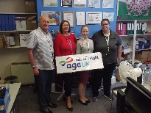

Prizes
£1,500 to the overall winning organisation
£500 to the overall runner up organisation
£300 each to the winning organisation in each category
£150 each to the runner up organisation in each category
£100 each to the third place organisation in each category

How to enter
Get an application from:
 www.communityactioniw.org.uk
 acoyle@actioniw.org.uk
 01983 524058
 Riverside, The Quay, Newport

Return applications to:
acoyle@actioniw.org.uk
CAIW, Riverside, The Quay, Newport
The closing date for the competition is 4pm on Friday 18th May 2018. Any entries received after this date and time will not be considered. Please note organisations can only enter up to two categories.
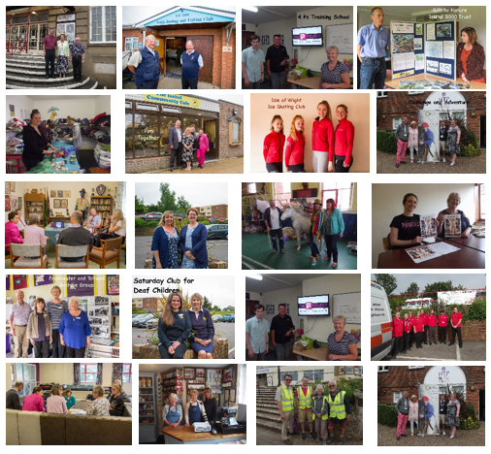


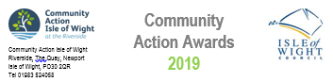
Main Sponsor | The Isle of Wight Council works in partnership with a  wide variety of voluntary and community organisations,  putting Islanders at the heart of everything we do. We  are therefore proud to support the Community Action  Awards which help to recognise the contribution these  groups make in our communities.
Category Sponsors

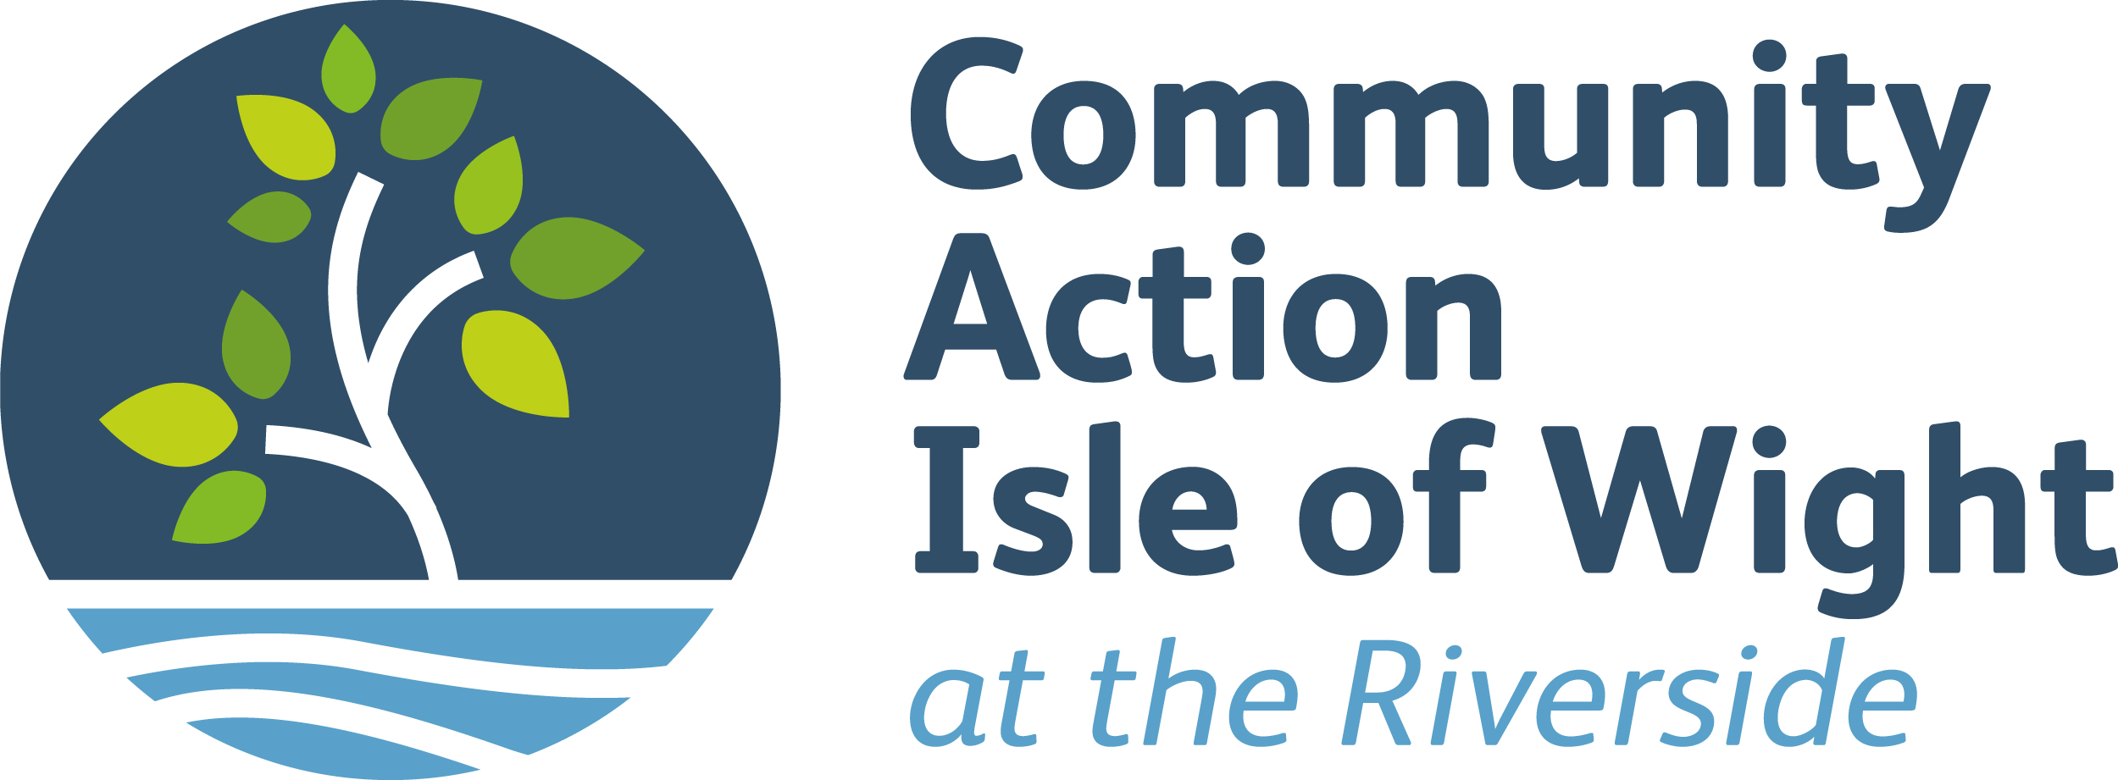 | Sport
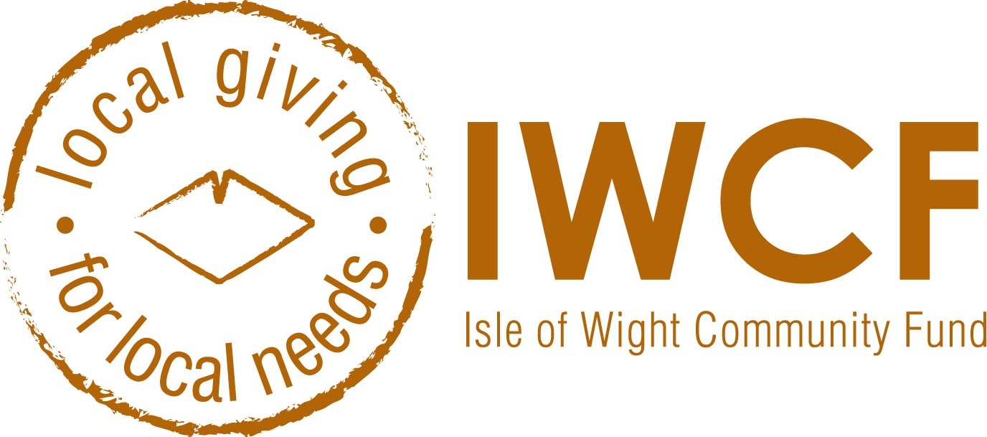 | Children & Young People
 | Older People
 | Village Halls & Community  Buildings
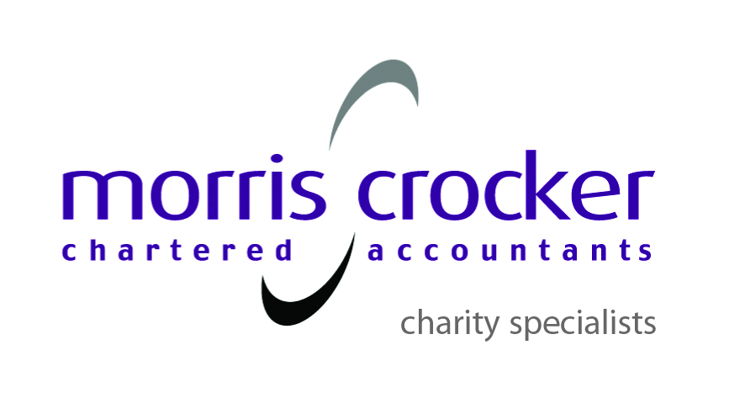 | Arts & Heritage
 | Local Communities
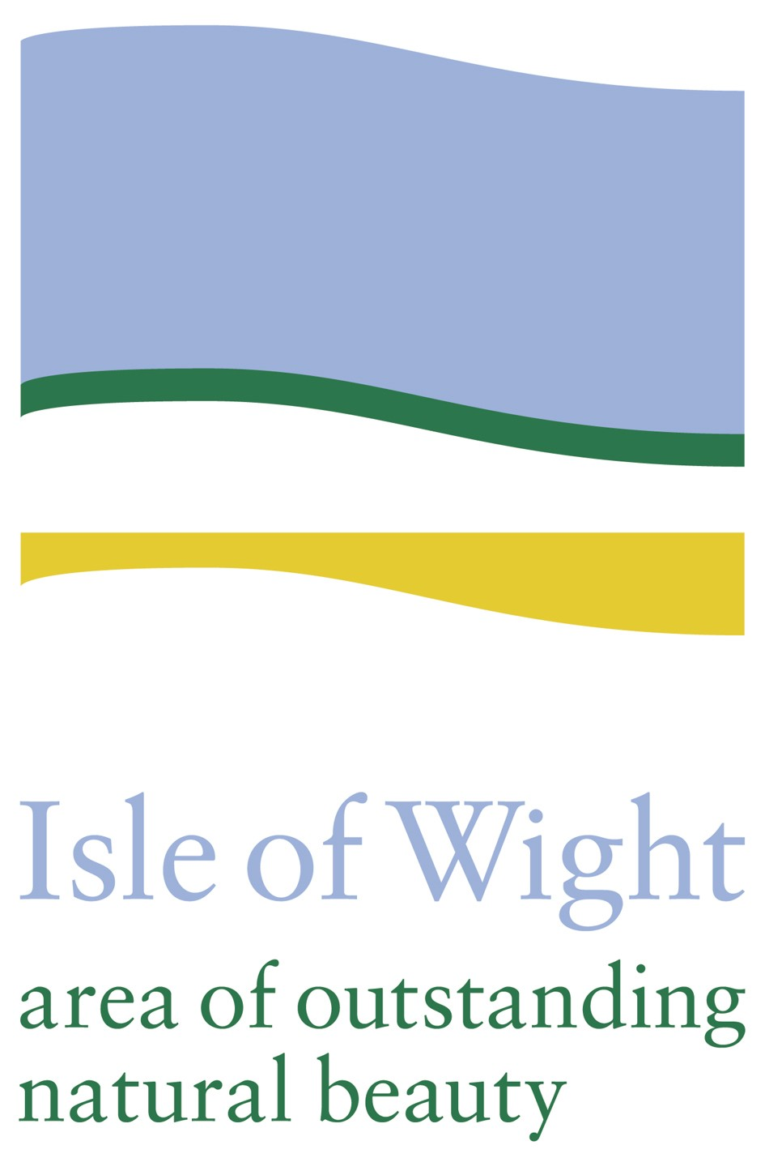 | Environment

Helping Communities Help Themselves
Riverside, The Quay, Newport,
Isle of Wight PO30 2QR Tel: 01983 524058
www.communityactioniw.org.uk
Registered charity No. 1063737 Company Registration No. 3340032

