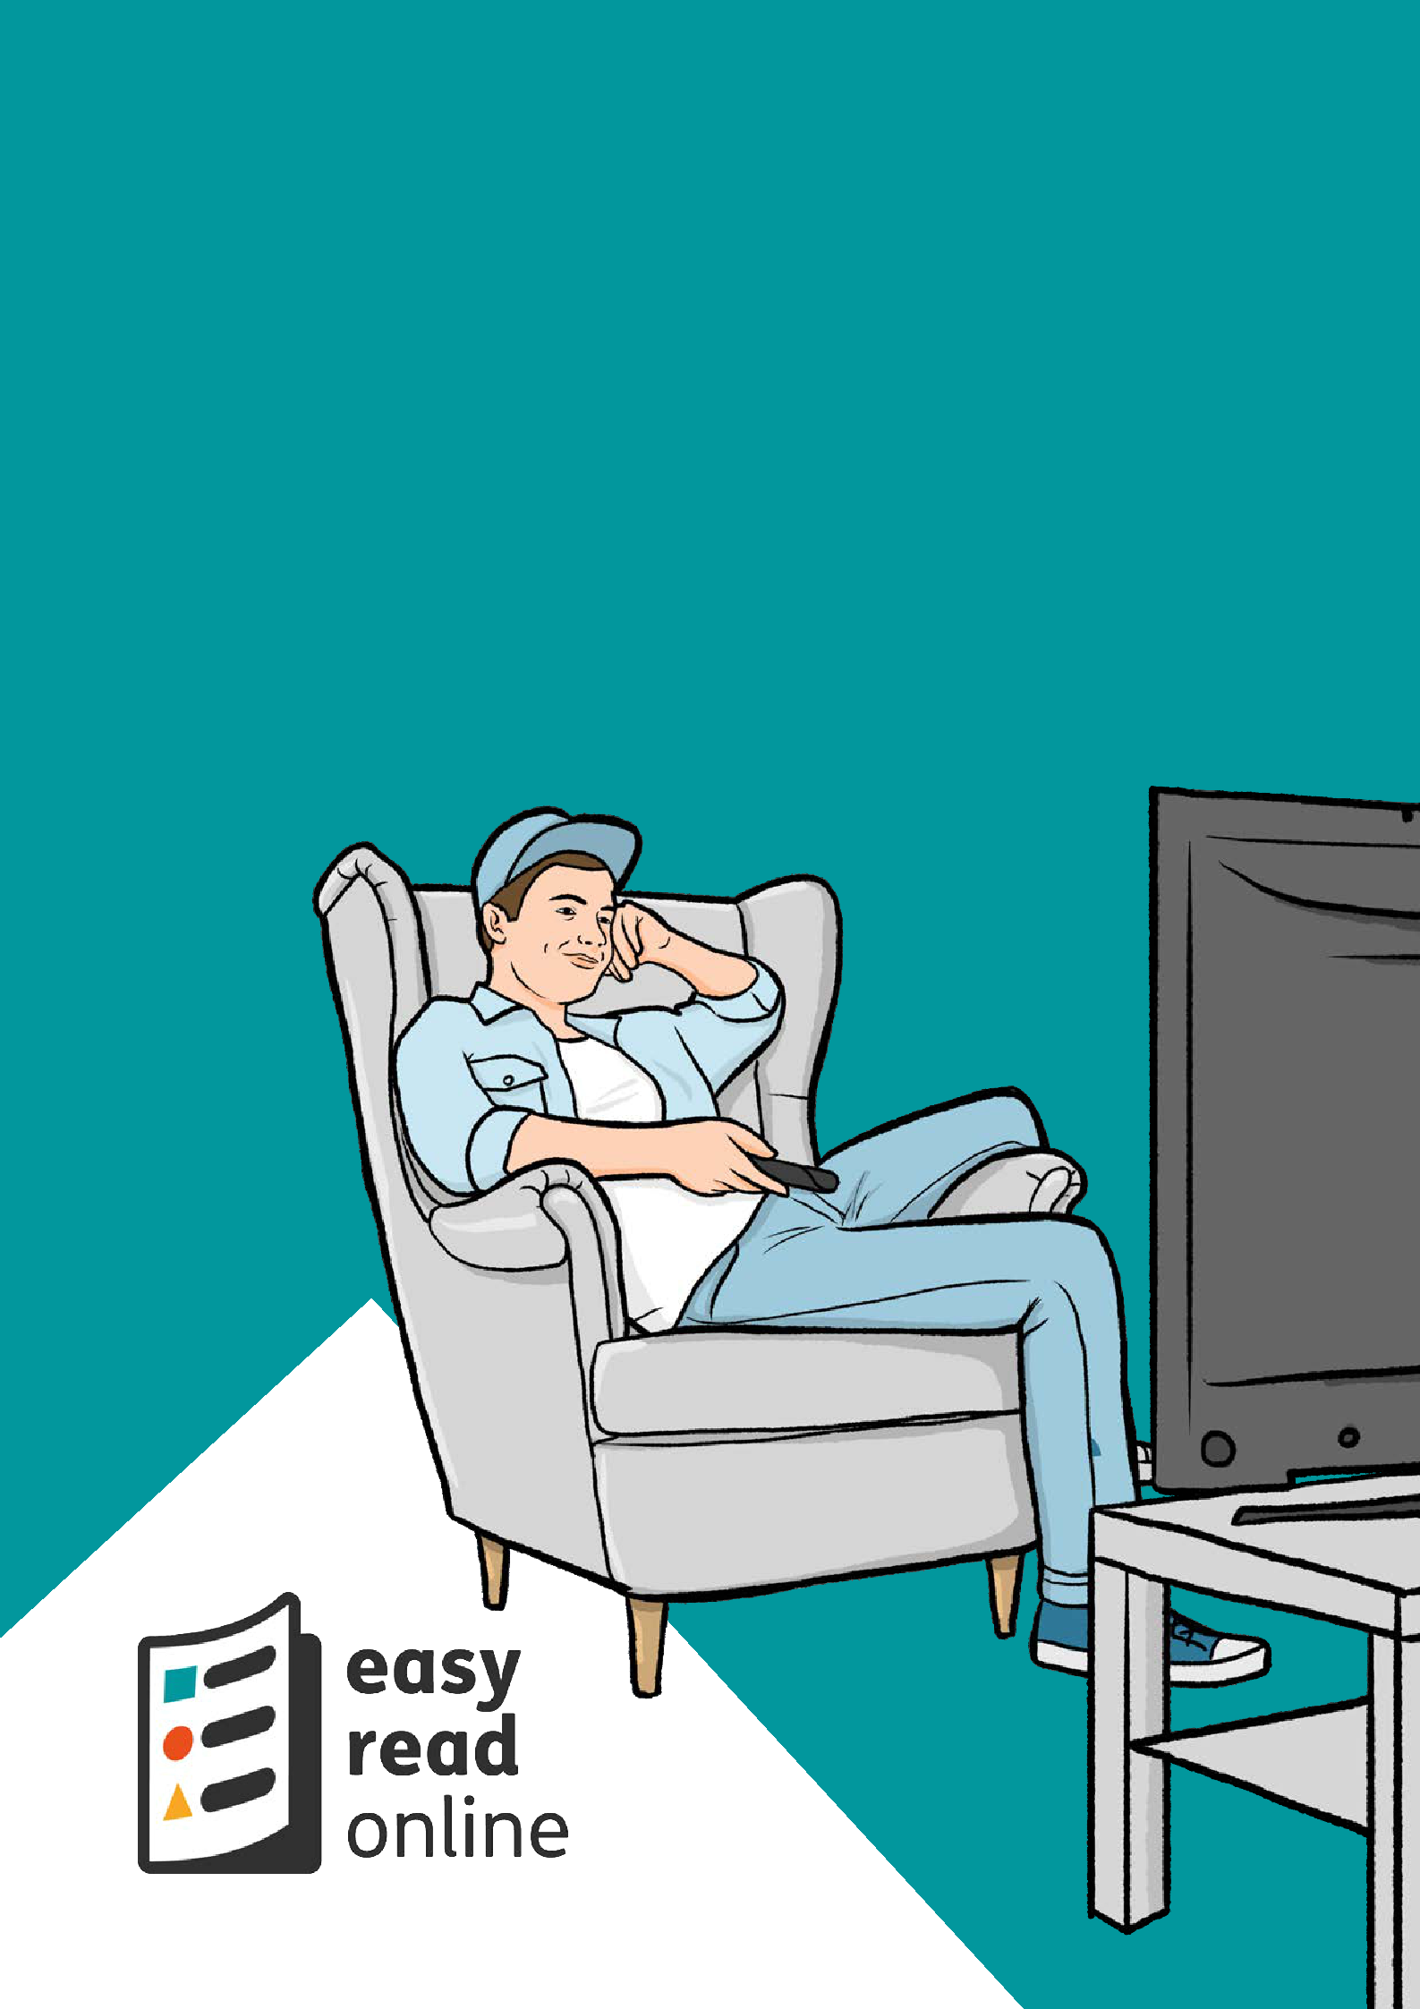
New rules on staying at home and away from others

read

on line

Introduction


easy
read
online
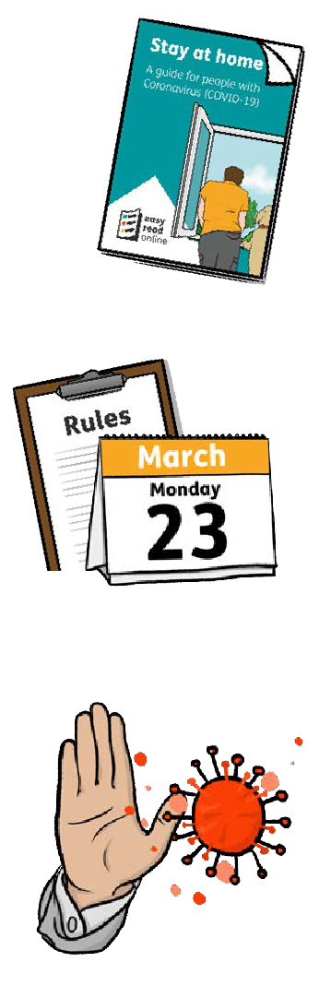

• •
• • •

This Easy Read information comes from Easy Read Online.

It is based on the Government’s new rules on staying at home and away from others.

These new rules were explained by the Prime Minister, Boris Johnson on the television on Monday, 23 March 2020.

These new rules will help to stop the spread of Coronavirus.
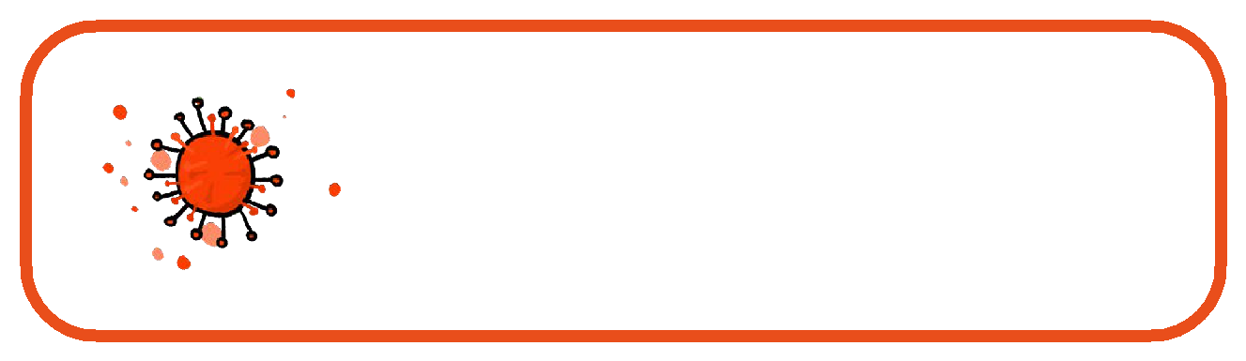

Coronavirus is a new illness that can affect your lungs and breathing. It is spreading around the world.

2

Saving people’s lives

By following these rules you will be helping to:

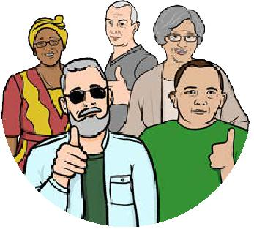 •
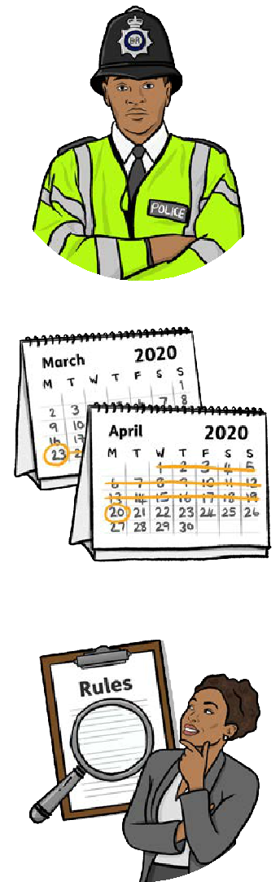


save people’s lives.

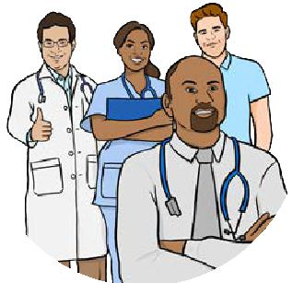 •

protect health services.

Everybody must follow these new rules.

The police will make sure that people follow these rules.

2020

The new rules start straight away and will last for at least 3 weeks.

The Government will look at the rules again in 3 weeks, to see if they are still needed.

3

Staying at home
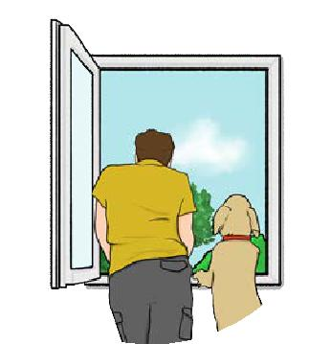

You must stay at home.

You should only leave your home for one of these reasons:
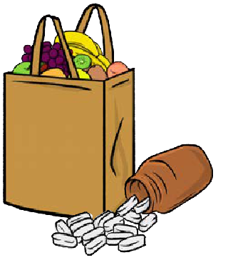

- Shopping for the things you need to live.

This means food and medicines.

- One type of exercise a day.

This could be a walk, a bicycle ride or a run.

You must do this on your own or with someone from your household.
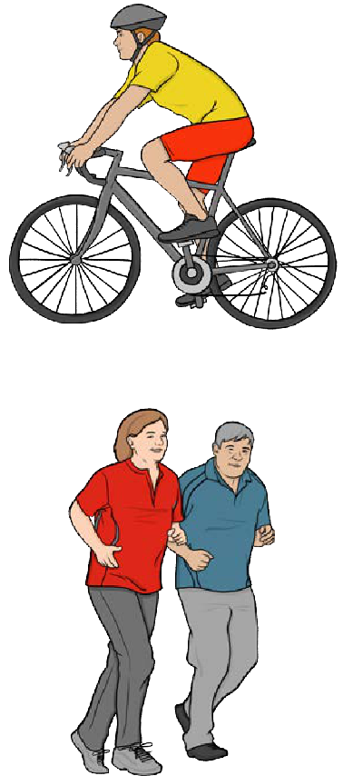

4

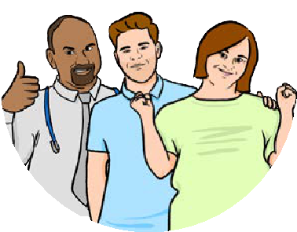

- Any medical need or to help a vulnerable person.

- Travelling to and from work.

This is only for people who cannot work from home.
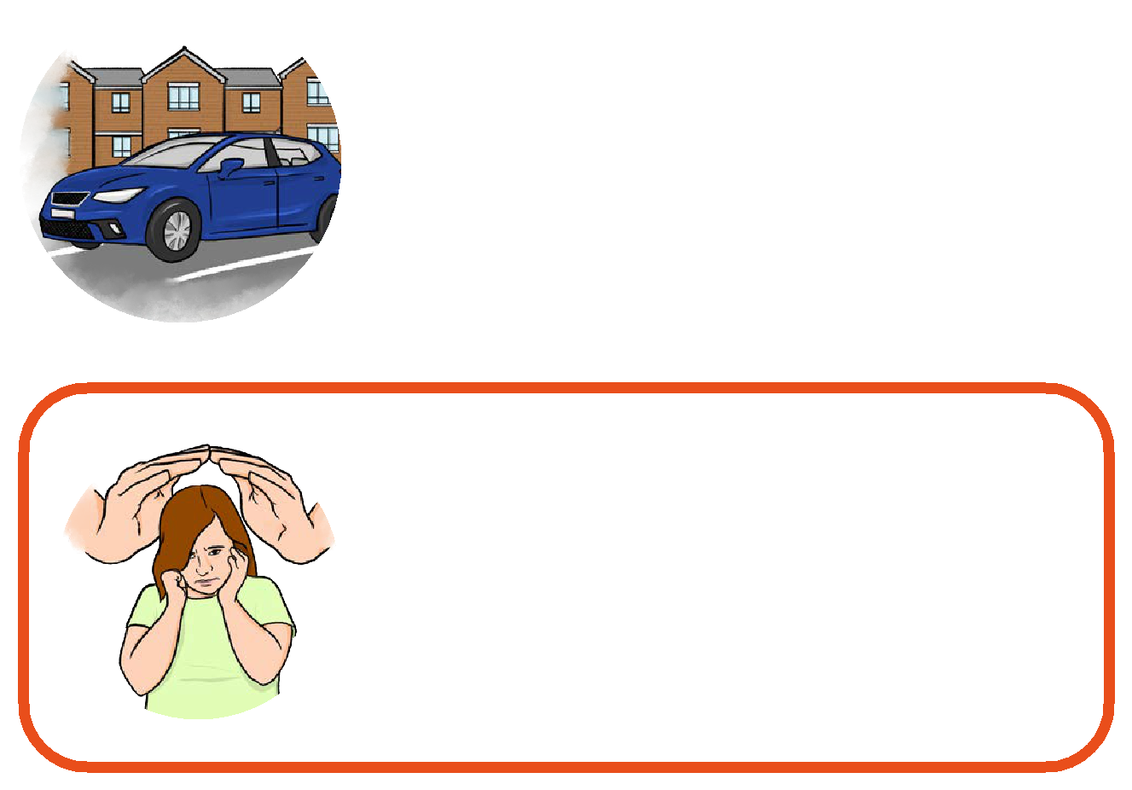

A vulnerable person is someone who fnds it diffcult to keep themselves safe.

5

If you do go out
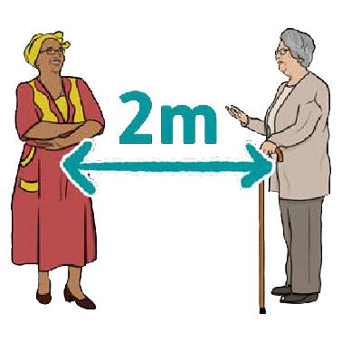

If you do go out you should:

- keep at least 2 metres apart from other people. This is just over 6 feet.

- stay out for as little time as possible.
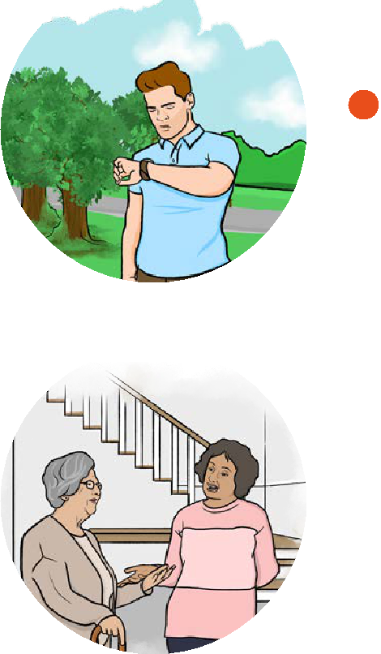

You don’t have to be 2 metres away from people who live in the same house as you.

6

Don’t get together with other people
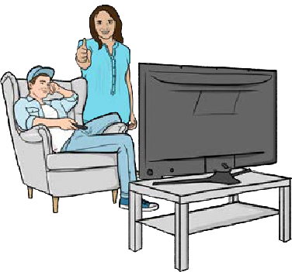

You should not meet up with other people unless:

•
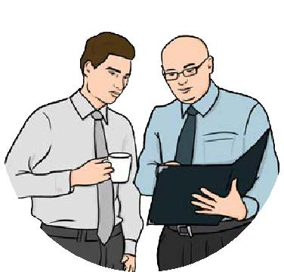

they live in the same house as you.

•
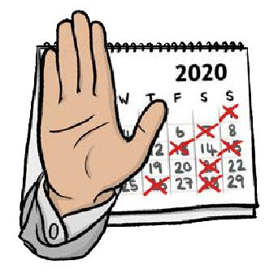

you have to meet with them as part of your work.

The Government is stopping all social events, including weddings and religious services except funerals.

7

More about Coronavirus
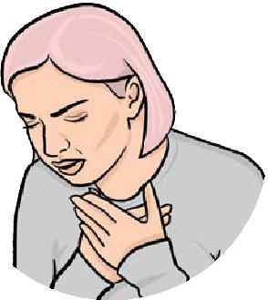

It is very easy to catch Coronavirus.
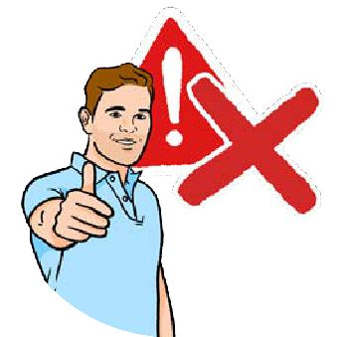

It is not serious for most people.
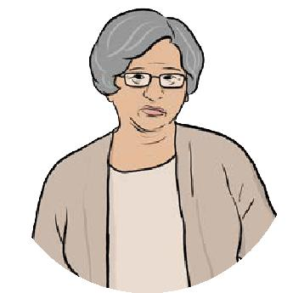

But it is serious for older people and people who have other health problems.
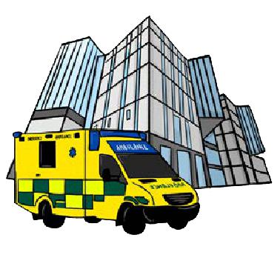

These people may have to go into hospital.
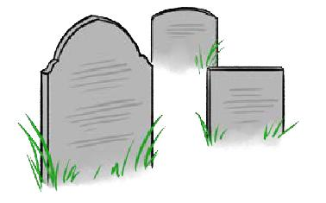

Some people are dying from Coronavirus.

8

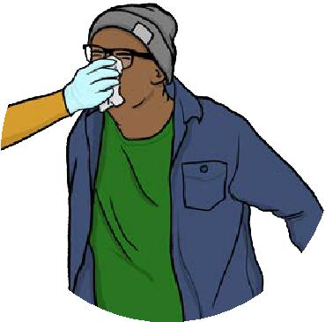
What’s it like?

Coronavirus feels like fu. You may have 1 or 2 or all of these things:
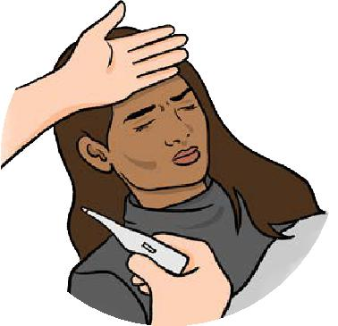

•
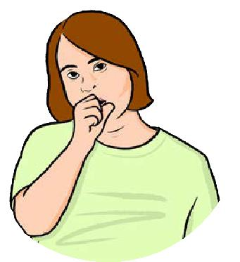

•

a high temperature.

a cough.

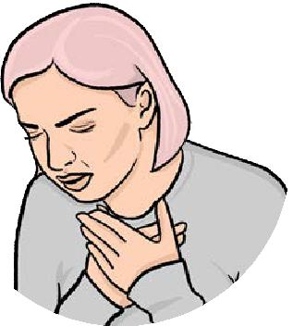 •
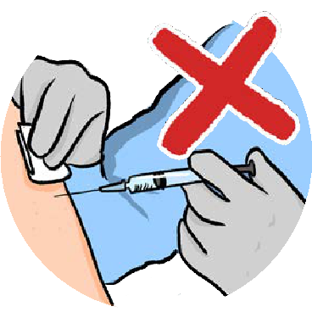

diffculty with breathing.

There is no vaccine at the moment. This means there is no jab to stop you getting it.

9

If you catch Coronavirus:

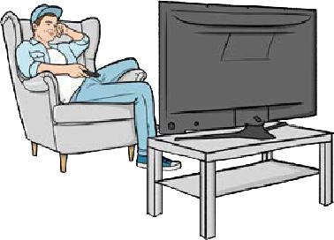 •

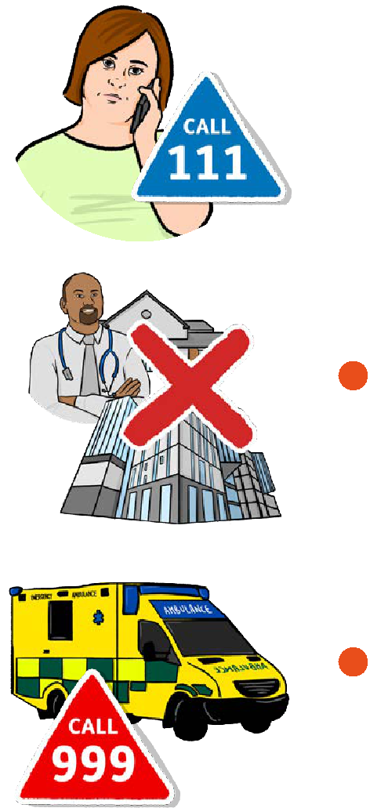

keep away from others and stay at home.

• if_{days:}you do not get better after 7

c:::±6II | • | go to www.NHS.uk for more
 | • | information.

  - if you have no internet phone NHS 111 for advice.

- don’t go to your local doctor, pharmacy or hospital.

- if there is an emergency call 999 straight away.

Easy Read by easy - read - online.co.uk

10

