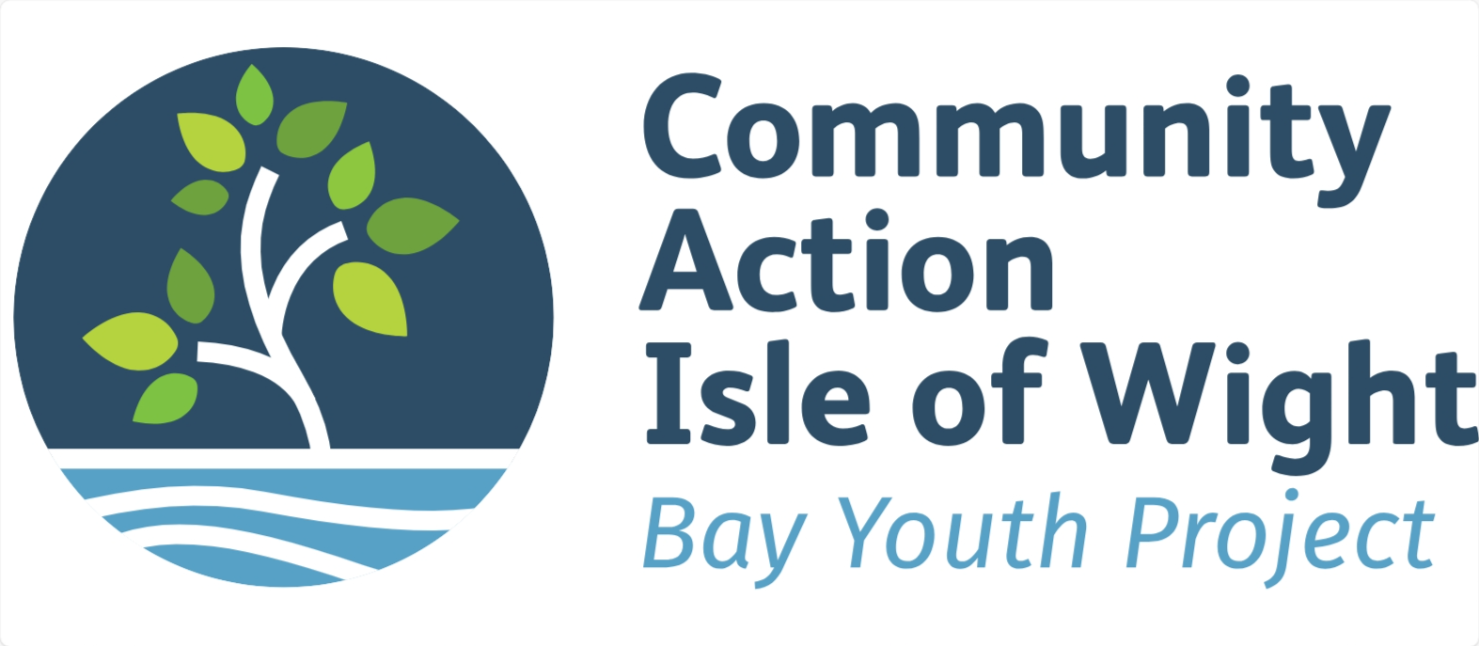

JOB DESCRIPTION
Post Title | Qualified Football Coach – Level 2
Salary and hours | 4-6 hours per week £15 to £20 per hour dependant on experience
Location | 2G facility at Sandham Gardens - Sandown
Accountable to | Bay Youth Project – Youth Intervention & Development Officer
How to Apply | Jwadsworth@actioniw.org.uk or for more information call Julian 07535 864 222

Purpose of Job
To support the Bay Youth Project diverse delivery across the Bay area we require a qualified football coach to design and lead football sessions for young people at the newly developed floodlit 2G pitch, at Sandham Gardens Sandown.
The coach will be supported by youth workers/sports workers.
The coach will develop fun and engaging grassroots football coaching sessions for mixed ability young people, aged 10-17 years, including those young people at the beginning of their football journey.
Plan, design and lead informal fun football leagues, that fully engage young people and encourage respect amongst participants.
Support young leaders into informal officiating roles around the league format and encourage volunteering.

ADDITIONAL REQUIREMENTS
There is an expectation that core delivery working hours will include twilight hours, evenings, including Friday nights and potentially holiday periods.
The postholder is expected to undertake other duties and responsibilities relevant to the post.

PERSON SPECIFICATION
Essential Experience and Skills

- Level 2 Football Coaching Qualification
- Safeguarding and First Aid certification’s (In date)
- Strong organisational skills, including time keeping and digital record keeping
- Strong team-working skills, including working with different staff members and partners.
- Strong communication skills, with young people, team members and partner agencies.
- Passionate in supporting young people to access sports and developmental opportunities, especially those who face barriers and challenges in their life
- Ability to travel to the Bay area for work.
- Understanding of professional boundaries.

Desirable experience and skills

- Experience of working within youth work, education sector or other relevant experience.
- Multi sports coaching qualifications and or experience

